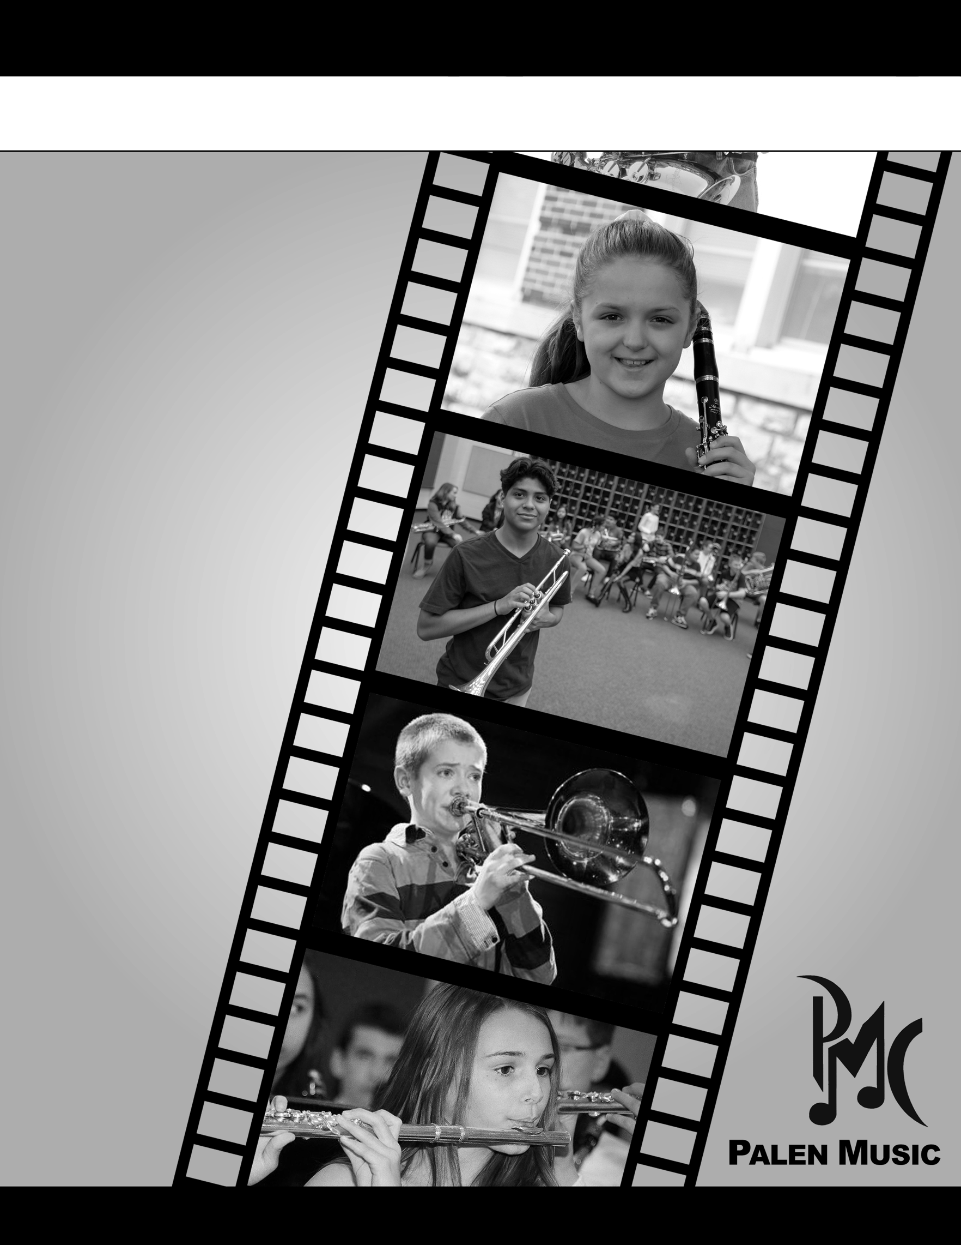

**CAN YOU PICTURE YOURSELF**

**PLAYING AN INSTRUMENT?**

**WE CAN!**

**PLEASE LET US HELP YOU**

**GET STARTED!**

When you are ready for your

instrument, please give us

the opportunity to serve you.

Visit our store or for an even

easier option, check out our

online rental portal:

**palenmusic.com/rent**

**COME TO THE INSTRUMENT RENTAL NIGHT AT THE BAND ROOM**

**THURSDAY, AUGUST 20th 4:30-6:30 PM**

**MONTHLY RENTAL RATES**

Flute $24.95-$32.95

Clarinet $24.95-$32.95

Saxophone $52.95-$62.95

Trumpet $28.95-$37.95

Trombone $28.95-$37.95

Baritone $56.95-$62.95

Percussion $24.95-$26.95

Note: Reconditioned rentals

are available as supplies last.

PALEN MUSIC CENTER 929 N. Elm Place, Broken Arrow, OK 74012 (918) 286-1555

­­

**WELCOME TO THE DEWEY BAND PROGRAM!**